ROLL No: 241901100
NAME: Sanjay Kumar M
Experiment: 13

DESIGN A SIMPLE TOPOLOGY USING CISCO PACKET TRACER

AIM:
To design a simple network topology using Cisco Packet Tracer that includes one router, two switches, and multiple PCs, and to configure them for successful communication.
INTRODUCTION:
Cisco Packet Tracer is a powerful network simulation tool that allows users to design, configure, and test computer network topologies virtually. By using routers, switches, and PCs, students and professionals can build and practice real-world networking scenarios without physical hardware. In this experiment, a simple topology with one router, two switches, and multiple PCs is designed to demonstrate basic device setup and connectivity
ALGORITHM:
- Open Cisco Packet Tracer and create a new project workspace.
- Add Devices:
- Drag one router, two switches, and multiple PCs onto the workspace.
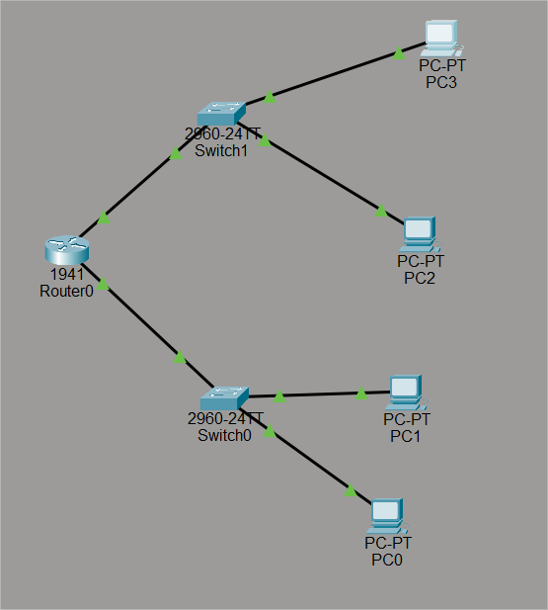
- Connect Devices:
- Use straight-through cables to connect each PC to a switch.
- Connect each switch to a separate interface on the router.
- Assign IP Addresses:
- Set appropriate IP addresses for each PC in their respective subnets.
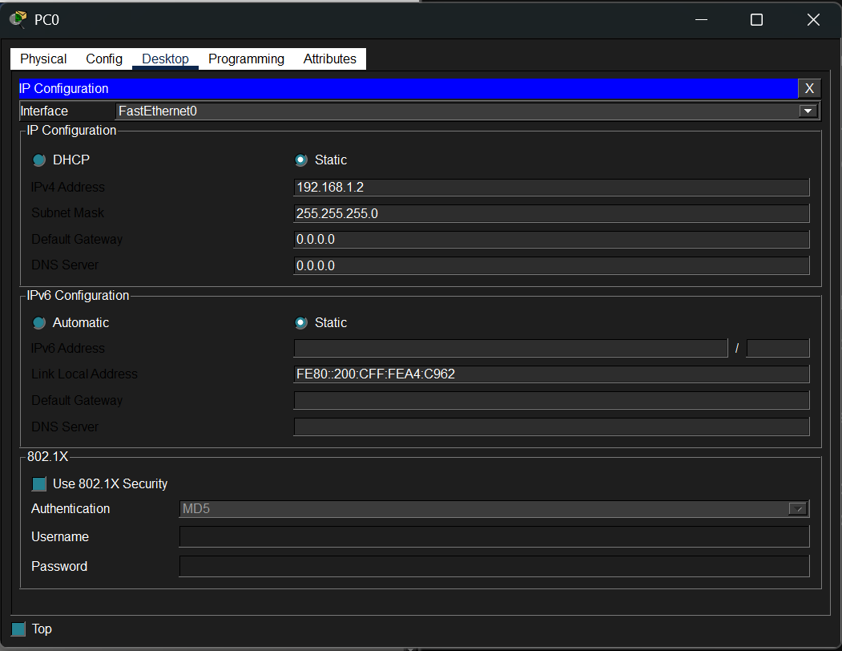
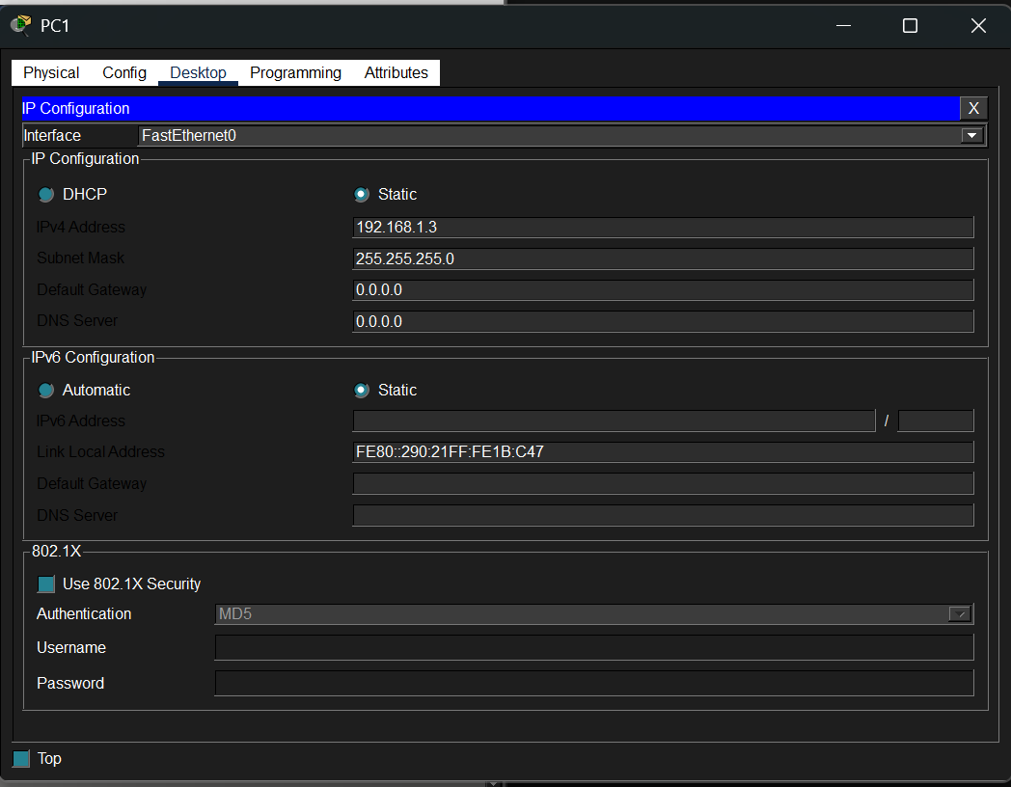
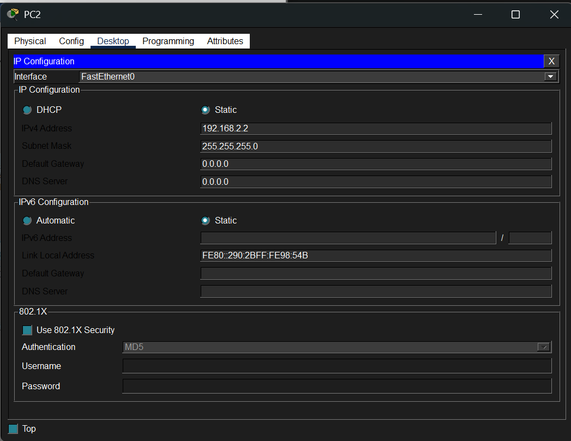
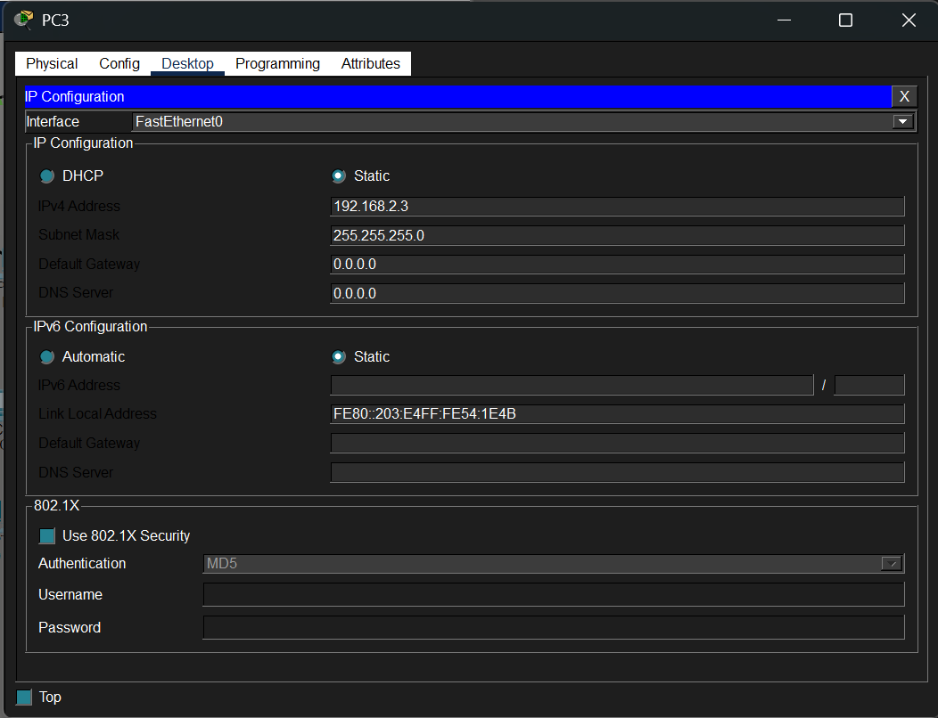

- Configure Router Interfaces:
- Access the router CLI and assign IP addresses to each connected interface.
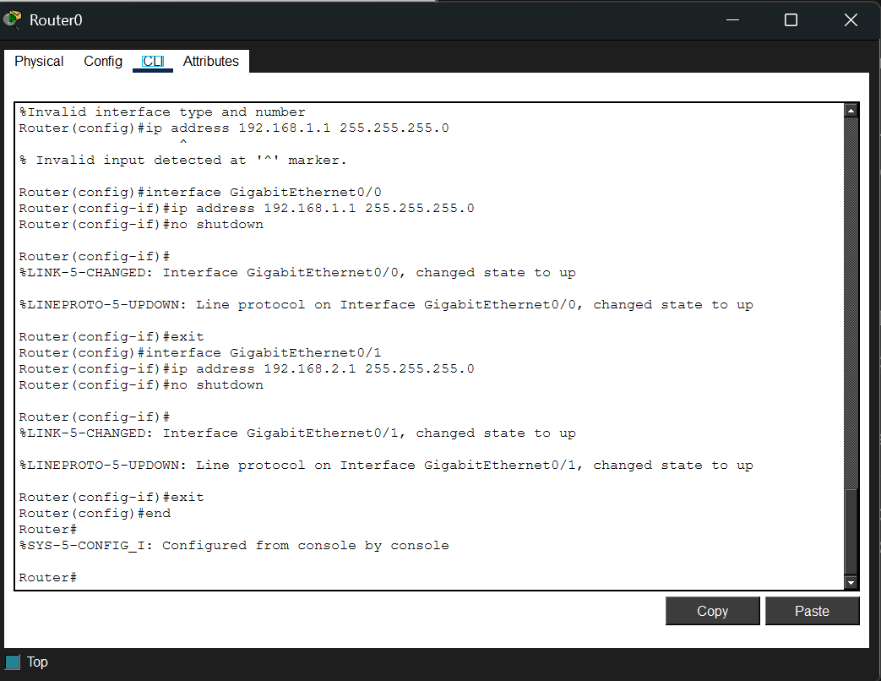
- Set Default Gateway:
- Configure each PC’s default gateway to match the router interface IP on its subnet.
- Verify Connectivity:
- Use the 'ping' command on PCs to check network communication across the topology.
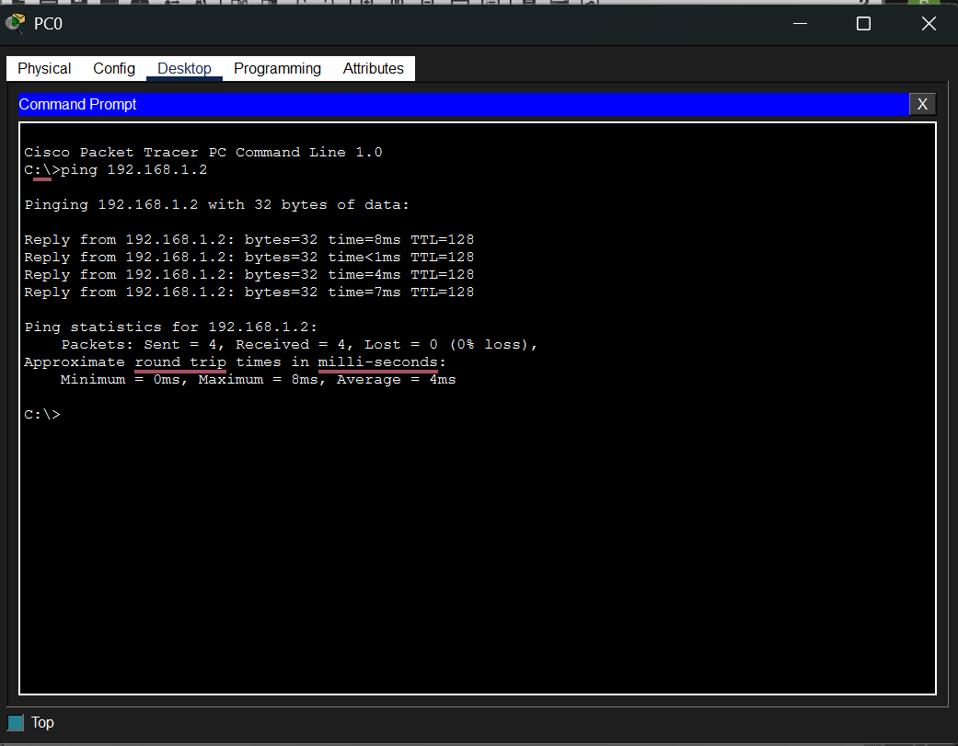
RESULT:
The designed topology, consisting of one router, two switches, and multiple PCs, was successfully configured. All devices were able to communicate with each other across the network, demonstrating correct network setup and connectivity verification using Cisco Packet Tracer.

